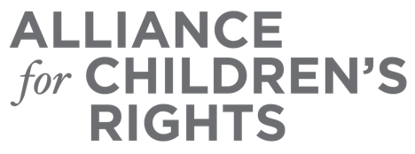

CERTIFICATE OF COMPLETION

Protecting the Financial Future of Foster Youth – An Advocate’s Guide to Addressing Foster Youth Identity Theft

Presenters:
Andrew Cain

This certifies that attended the 2 hour “Protecting the Financial Future of Foster Youth – An Advocate’s Guide to Addressing Foster Youth Identity Theft” Webinar Training on September 21, 2022.

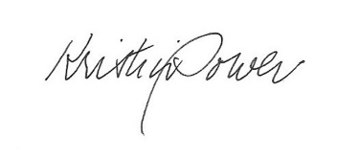

Attendee Signature Kristin Power
VP, Policy and Advocacy
Alliance for Children’s Rights

