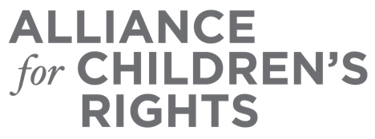

CERTIFICATE OF COMPLETION

2022 Budget Allocations and New Laws: Supporting Children and Youth in Foster Care

Presenters:
Sabrina Forte
Anna Johnson
Amanda Kirchner
Susanna Kniffen
Blair Kreuzer
Kim Lewis
Jenny Pokempner
Kristin Power
Adrienne Shilton
Luciana Svidler

This certifies that attended the 2 hour “2022 Budget Allocations and New Laws: Supporting Children and Youth in Foster Care” Webinar Training on October 26, 2022.

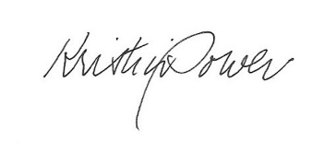

Attendee Signature Kristin Power
VP, Policy and Advocacy
Alliance for Children’s Rights

