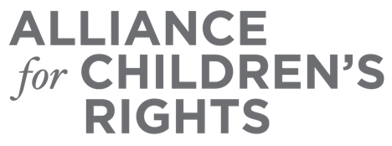

CERTIFICATE OF COMPLETION

Changes to Laws and Policies to Support Families Impacted by COVID-19: What’s New?

Presenters:

Angie Schwartz
Sue Abrams
Kathy Yang
Sara Rogers
Cathy Senderling-McDonald

This certifies that attended the 2 hour “Changes to Laws and Policies to Support Families Impacted by COVID-19: What’s New?” Webinar Training on October 21, 2020.

Attendee Signature Angie Schwartz
VP, Policy and Advocacy
Alliance for Children’s Rights

