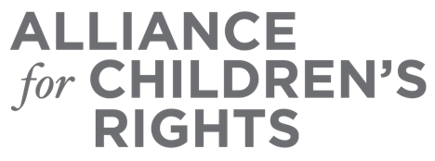

CERTIFICATE OF COMPLETION

Engaging Lived Experience in the Policy Making Process

Presenters:
Taneil Franklin
Brisia Gutierrez
Jenn Rexroad

This certifies that attended the 2 hour “Engaging Lived Experience in the Policy Making Process” Webinar Training on November 16, 2022.

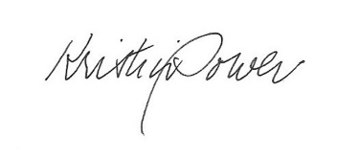

Attendee Signature Kristin Power
VP, Policy and Advocacy
Alliance for Children’s Rights

