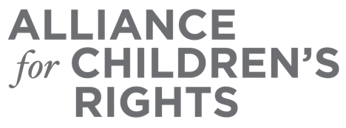

CERTIFICATE OF COMPLETION

Modifications to Extended Foster Care in Response to COVID-19

Presenters:

Sue Abrams
Julie McCormick
Cindy Vatalaro
Tina Vartanian
Angie Schwartz

This certifies that attended the 2 hour “Modifications to Extended Foster Care in Response to COVID-19” Webinar Training on November 6, 2020.

Attendee Signature Angie Schwartz
VP, Policy and Advocacy
Alliance for Children’s Rights

