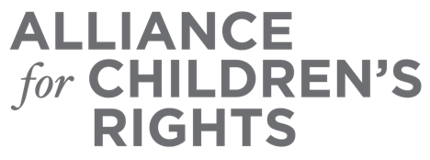

CERTIFICATE OF COMPLETION

Child Welfare Advocates Proposals: 2021 California Child Welfare Bills and Budget Requests

Presenters:

Susanna Kniffen
Julie McCormick
Diana Boyer
Amy Lemley
Kim Lewis
Jessica Maxwell
Kristin Power

This certifies that attended the 2 hour “Child Welfare Advocates Proposals: 2021 California Child Welfare Bills and Budget Requests” Webinar Training on March 24, 2021.

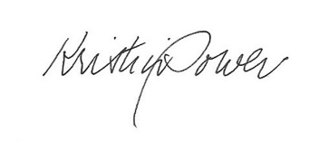

Attendee Signature Kristin Power
VP, Policy and Advocacy
Alliance for Children’s Rights

