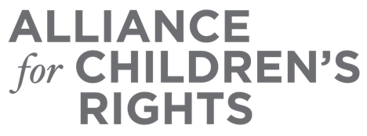

CERTIFICATE OF COMPLETION

Supporting Older Teens: Access to Systems and Services

Presenters:
Daniel Richardson
Kim Lewis
Maighna Jain
Sabrina Forte

This certifies that attended the 2 hour “Supporting Older Teens: Access to Systems and Services” Webinar Training on June 29, 2022.

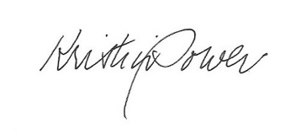

Attendee Signature Kristin Power
VP, Policy and Advocacy
Alliance for Children’s Rights

