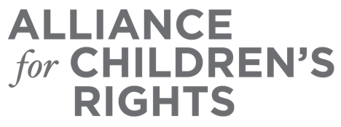

CERTIFICATE OF COMPLETION

Foster Youth Rights and County Responsibilities: What You Need to Know About SSI

Presenters:
Marisa Lopez-Scott
Sarah Manimalethu
Joanna Parnes
Steve Weiss

This certifies that attended the 2 hour “Foster Youth Rights and County Responsibilities: What You Need to Know About SSI” Webinar Training on June 21, 2023.

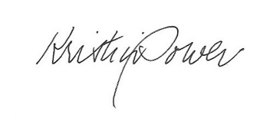

Attendee Signature Kristin Power
VP, Policy and Advocacy
Alliance for Children’s Rights

