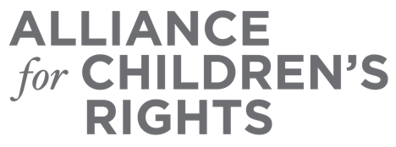

CERTIFICATE OF COMPLETION

Family Law and Restraining Orders 101: Navigating Family Court

Presenters:
Juan Navarcia
Rachel Stein
Sharon Balmer Cartegena

This certifies that attended the 2 hour “Family Law and Restraining Orders 101: Navigating Family Court” Webinar Training on July 27, 2022.

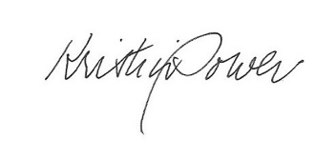

Attendee Signature Kristin Power
VP, Policy and Advocacy
Alliance for Children’s Rights

