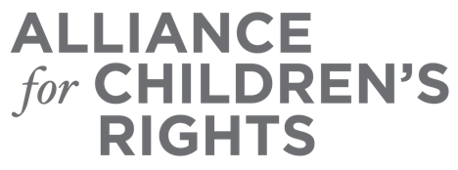

CERTIFICATE OF COMPLETION

Navigating Probate and Dependency Courts Under AB 260

Presenters:
Sabrina Forte
Juan Guzman
Sarah Saria
Sydney Steinkohl

This certifies that attended the 2 hour “Navigating Probate and Dependency Courts Under AB 260” Webinar Training on January 25, 2023.

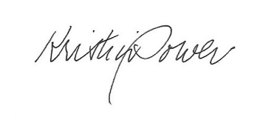

Attendee Signature Kristin Power
VP, Policy and Advocacy
Alliance for Children’s Rights

