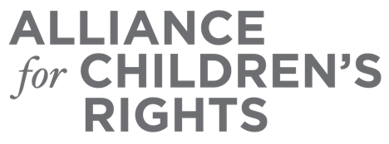

CERTIFICATE OF COMPLETION

Disability Rights in Child Care Settings

Presenters:
Giani Interiano Brown

This certifies that attended the 2 hour “Disability Rights in Child Care Settings” Webinar Training on February 15, 2023.

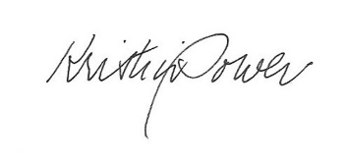

Attendee Signature Kristin Power
VP, Policy and Advocacy
Alliance for Children’s Rights

