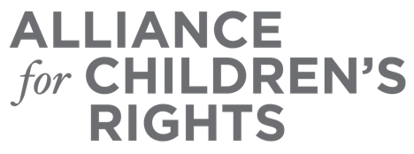

CERTIFICATE OF COMPLETION

Improving Educational Outcomes: Educational Rights Holder Appointment and Responsibilities

Presenters:

Alaina Moonves-Leb
La Shona Jenkins
Elizabeth Solares

This certifies that attended the 2 hour “Improving Educational Outcomes: Educational Rights Holder Appointment and Responsibilities” Webinar Training on December 10, 2020.

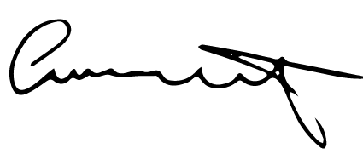

Attendee Signature Angie Schwartz
VP, Policy and Advocacy
Alliance for Children’s Rights

