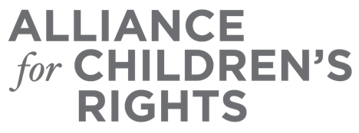

CERTIFICATE OF COMPLETION

Wraparound for All Systems-Involved Youth: A Practical Overview of Legal Entitlements and Advocacy Under CalAIM and Beyond

Presenters:
Brian Blalock
Rachel Murphy
Sabrina Forte

This certifies that attended the 2 hour “Wraparound for All Systems-Involved Youth: A Practical Overview of Legal Entitlements and Advocacy Under CalAIM and Beyond” Webinar Training on August 24, 2022.

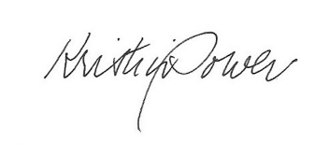

Attendee Signature Kristin Power
VP, Policy and Advocacy
Alliance for Children’s Rights

