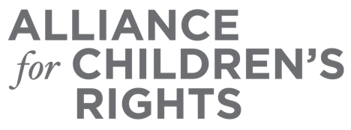

CERTIFICATE OF COMPLETION

Housing Options, Rights, Responsibilities, and Resources for Non-Minor Dependents

Presenters:
Christine Bradshaw
Alero Egbe
Lindsay Verity

This certifies that attended the 2 hour “Housing Options, Rights, Responsibilities, and Resources for Non-Minor Dependents” Webinar Training on August 16, 2023.

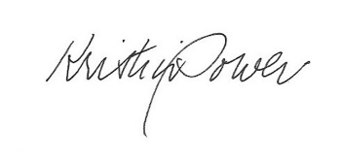

Attendee Signature Kristin Power
VP, Policy and Advocacy
Alliance for Children’s Rights

