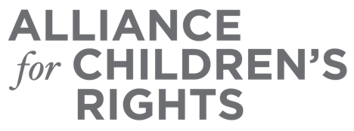

CERTIFICATE OF COMPLETION

Status of School Stability and Transportation in California: Ensuring Youth in Foster Care Can Access their School of Origin

Presenters:
Jill Rowland
Alaina Moonves-Leb
Danielle Wondra

This certifies that attended the 1.5 hour “Status of School Stability and Transportation in California: Ensuring Youth in Foster Care Can Access their School of Origin” Webinar Training on April 29, 2021.

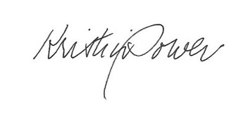

Attendee Signature Kristin Power
VP, Policy and Advocacy
Alliance for Children’s Rights

