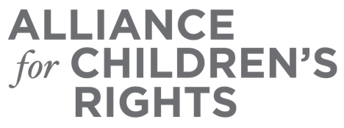

CERTIFICATE OF COMPLETION

Child Care Options: Accessing Available Resources

Presenters:
Kim Lewis
Eva Chou
Candy Duperroir
Laurie Furstenfeld

This certifies that attended the 2 hour “Child Care Options: Accessing Available Resources” Webinar Training on April 27, 2022.

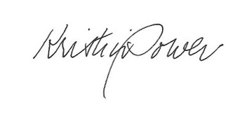

Attendee Signature Kristin Power
VP, Policy and Advocacy
Alliance for Children’s Rights

