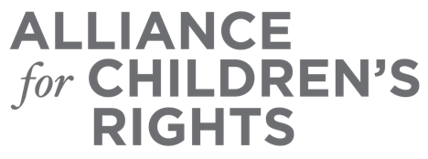

CERTIFICATE OF COMPLETION

2023 Bills and Budget Requests

Presenters:
Michelle Castagne
Amanda Kirchner
Susanna Kniffen
Kim Lewis
Julie McCormick
Rachel Murphy
Jessica Petrass
Kristin Power
Adrienne Shilton
Jordan Sosa

This certifies that attended the 2 hour “2023 Bills and Budget Requests” Webinar Training on April 12, 2023.

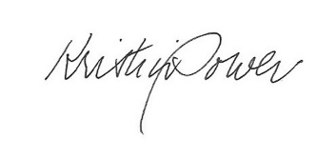

Attendee Signature Kristin Power
VP, Policy and Advocacy
Alliance for Children’s Rights

