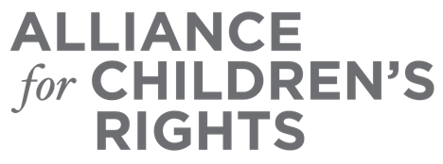

CERTIFICATE OF COMPLETION

FYI Vouchers – Flipping the Script: From Housing Crisis for Foster Youth to Solution

Presenters:
Ruth White

This certifies that attended the 2 hour “FYI Vouchers – Flipping the Script: From Housing Crisis for Foster Youth to Solution” Webinar Training on April 7, 2021.

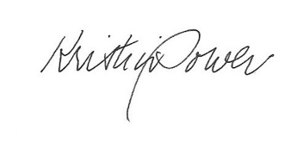

Attendee Signature Kristin Power
VP, Policy and Advocacy
Alliance for Children’s Rights

