Caregiver Friendly Courtrooms: Understanding the Juvenile Court Process and Making it More Accessible for Families

Presenters:
Susan Abrams
Anabel & David Meldrum
Cherie Schroeder
Angie Schwartz
Katelyn Woods

kids-alliance.org

This certifies that attended the 2 hour “Caregiver Friendly Courtrooms: Understanding the Juvenile Court Process and Making it More Accessible for Families” Webinar Training on January 30, 2019.
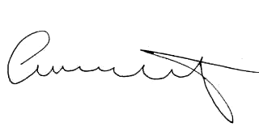

Attendee Signature Angie Schwartz

