Voices of Kinship Caregivers

Presenters:
Bob Ruble
Cherie Weatherall
Linda Leighton
Lydia Perez
Marcelina Valenzuela
Mary Lee

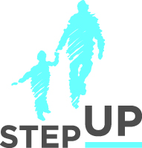

stepupforkin.org

This certifies that attended the 2 hour Webinar Training Voices of Kinship Caregivers Webinar on May 25, 2016.
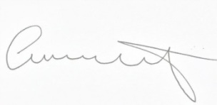

Attendee Signature Angie Schwartz

